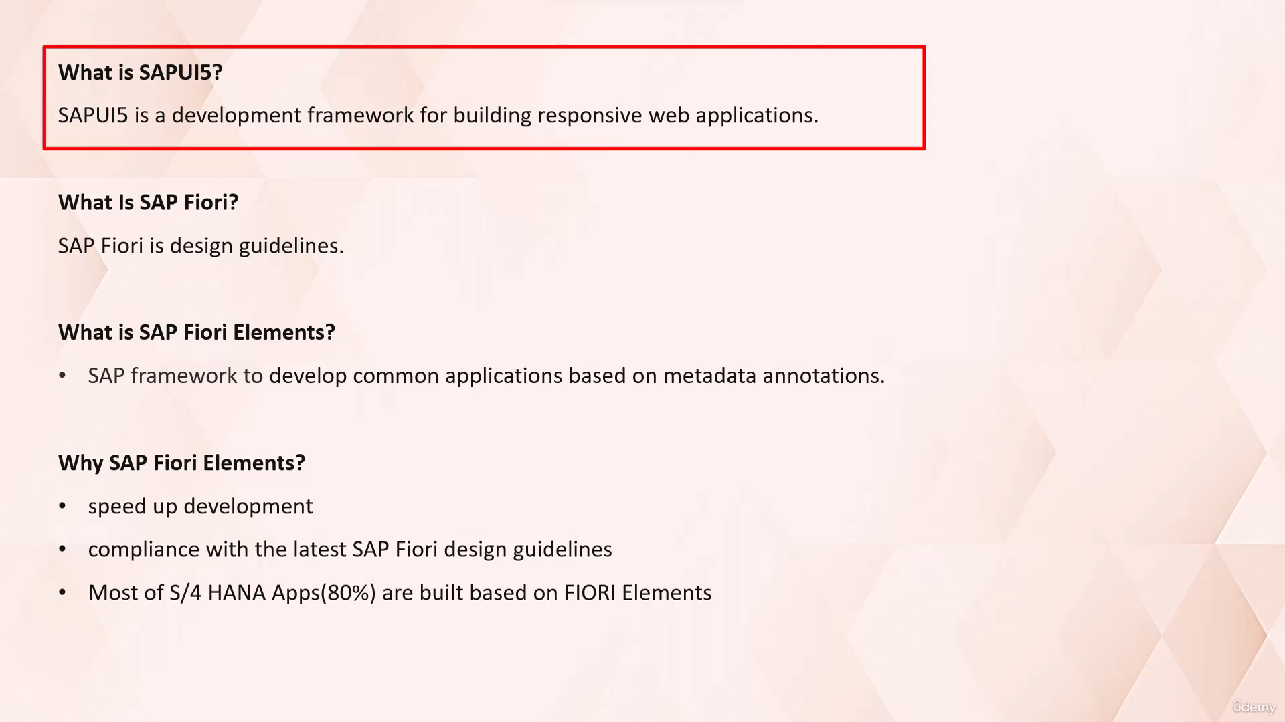

In this video tutorial, I will discuss with you about the common terminologies using active front end

development such as SAP Uf5, SAP Fiori and we will discuss what is SAP Fiori elements and how we can

use it to create the SAP Fiori application.

So let's start.

Let's understand what is SAP UI file.

SAP.

UI Uf5 is a development framework for building responsive web applications.

Here, responsive means that the web applications adapt their UI to desktop, tablet, and mobile devices

with freestyle Uf5 development.

Developers have the option to design applications according to their own preferences, potentially resulting

in variations of the design of SAP applications.

SAP Fiori is not a technology.

SAP Fiori is a design guidelines that determines how UI looks and feels.

A SAP Fiori is a collection of rules for how the user experience of SDP application is supposed to be,

and how an SAP application is supposed to appear.

Most of the business requirements required to display tables, forms, and charts of the applications

to reduce the amount of frontend code while developing the SAP Fiori application.

And to keep design consistent.

SAP introduces a framework to develop these common applications based on metadata annotations of OData,

which generate UI.

It's called active elements.

SAP Fiori Elements uses metadata annotations and predefined templates to generate Fiori applications

so developer can concentrate on back end coding and business logic.

With the goal of Fiori elements is to speed up development and drive UI consistency and compliance with

latest SAP Fiori design guidelines.

Most of standard SAP S four Hana applications, around 80%, are built based on Fiori Olympics.

Fiori element applications are generated by Fiori Element framework using annotations defined on OData

service and annotations from local application configuration.

These adaptations are interpreted by SAP Uf5 framework at runtime and data is displayed accordingly.

Abap developers can use SAP Fiori elements to create a SAP Fiori applications based on OData service

and annotations that doesn't need JavaScript UI coding.

The resulting Fiori apps uses predefined views and controllers that are provided centrally.

This means that no application specific view instances are required.

Now let's discuss about types of Fury element floorplans.

Overview page.

The SAP Fury overview page application is a type of floorplan with a UI framework that provides quick

access to vital business information at a glance.

As you can see in this image, an overview page is a data driven SAP Fiori application for organizing

large amounts of information in visualized format in an attractive and efficient way.

This is in the form of actionable cards on a single page enabling users to make faster decisions and

focus on their most important task.

It provides you with business critical information such as KPIs, quick links, contacts, and so on.

You can then interact with these objects to navigate to another page type for more information.

Now let's discuss about List Report floorplan.

It's a reusable floor plan template that used to create list report application.

It allows users to work with large list of items and act on each one.

A list report lets user filter view and work with the items organized in the list format.

As you can see here.

Now let's discuss about object page floorplan.

Object page is a type of floorplan template which allows users to display, create or edit an item in

list report.

Fury.

Application is typically used in conjunction with the object page.

In a typical SAP Fiori application created using SAP Fiori element frameworks, OData service annotation

decides what data to display, and SAP Fiori element page type decides how to display this data.

So in this video tutorial we will learn what is SAP Uf5.

What is SAP Fiori and how is it Fiori?

Element framework uses OData services with the annotations and floorplan template to create Fiori application.

That's all for now.

See you in next video tutorial.